**A REPORT ON APPLICATION TITLE**

**GAMERZ WEB APPLICATION**

A Report Submitted

In partial fulfillment of the requirements for the award of the degree of

**Bachelor of Technology**

**In**

**Information Technology**

**By**

**Student Name1:** T.Nanda Kishore **Roll No :** 20N31A12F0

**Student Name2:** Kethavath Sai **Roll No :**21N35A1213

**Student Name3:** Rahul Kumar **Roll No :**20N31A12D0

Under the esteemed guidance of

**Faculty Incharge**

**Designation**



**Department of Information Technology**

**Malla Reddy College of Engineering & Technology**

(Autonomous Institution- UGC, Govt. of India)

(Affiliated to JNTUH, Hyderabad, Approved by AICTE, NBA &NAAC with ‘A’ Grade)

Maisammaguda, Kompally, Dhulapally, Secunderabad – 500100

website: [www.mrcet.ac.in](http://www.mrcet.ac.in)

**2020-2024**



**Malla Reddy College of Engineering & Technology**

(Autonomous Institution- UGC, Govt. of India)

(Affiliated to JNTUH, Hyderabad, Approved by AICTE, NBA &NAAC with ‘A’ Grade)

Maisammaguda, Kompally, Dhulapally, Secunderabad – 500100

website: [www.mrcet.ac.in](http://www.mrcet.ac.in)

**CERTIFICATE**

This is to certify that this is the bonafide record of the application entitled “GAMERZ WEB APPLICATION”, submitted by T.Nanda Kishore(20N31A12F0), Kethavath Sai (21N35A1213) and Rahul Kumar (20N31A12D0) of B.Tech in the partial fulfillment of the requirements for the degree of Bachelor of Technology in Information Technology, Department of IT during the year 2022-2023. The results embodied in this application report have not been submitted to any other university or institute for the award of any degree or diploma.

**Faculty Incharge Head of the Department**

**Ramya Sree Dr. G.Sharada**

**External Examiner**

**TABLE OF CONTENTS**

**S.NO TITLE PG.NO**

1. **INTRODUCTION 04**
2. **APPLICATION DESCRIPTION 06**
3. **RESULT 11**
4. **CONCLUSION 17**
5. **FUTURE ENHANCEMENTS 18**

**INTRODUCTION**

**OBJECTIVES**

In the fast growing field of software engineering and development one of the fastest growing sectors is Gaming Industry. In 1952 A.S. DOUGLAS invented the first game like version of tic-tac-toe which is a first graphical game. As the technology in the gaming field increasing, the number of players are also increasing day by day. Our main motive is to develop a GAMERZ website which doesn’t contain any ad’s and in that the games are free from viruses and third parties. Here the users can browse all the games they want. The users can also find there interested games easily.

The gaming sector is taking leaps with advancements in technology. With artificial intelligence, augmented reality, and mobile technology-games are getting some major upgrades. The extensive range of games entering the market is attracting a diverse demographic.

Companies are racing to tap into new customers and communities. It is crucial that they are equipped with a content marketing strategy that raises their brand’s visibility.

In order to develop a web based game, we analyzed various available games and picked strategy game to be our choice. Various strategy games are available on internet, among them, one is business strategy game, so we chose to develop an Indian theme based business strategy game commonly known as monopoly. At the end of this project we aim to achieve following objectives:

• To develop the user interface of the game.

• To integrate user interaction in it.

• To develop and manage the back end of the game.

• To integrate game with social networking websites.

**Purpose :**

The purpose of this website is to provide best & latest games with latest updates. Our website interface will be very easy to understand and easy to use.From this website players can access and play the different games and we include the new games.

Gaming is an industry that grows fast, with new exciting games, more advanced graphics, and richer storylines produced every day. And as games improve, so does gaming website design. The internet is full of stunning game website examples and countless gaming website ideas that are worth exploring.

A gaming website is by far the most effective way to present your game to your target audience. You might be able to reach more people by blasting social media ads. But once your audience shows interest in your game, they’ll want to learn more about it through your website. This is where your gaming website UI design steps in to present your game in the best possible light.

**Aim :**

The application aims to develop an easy to use and an open source web application were the users can access and play multiple games. This application consists of many games from small games like ‘Tic Tac Toe’ to ‘GTA’. The main aim of the application is to provide a platform where the users or players can access and play various types of games in one website. The website provides the user based reviews on the games, so the players get to know about the gaming experience of the required game.

A good online game in one which engages users for a long time without boredom. According to a web article, following are the features of a good online game:

• A compelling and original concept

• Player support and community

• Great graphics and environmental diversity

• Good customer service

• Fun gameplay

• Add-on and mod support

• Built-in player-game matching service

• Content additions and refinements

• Ease of player interaction

• Accessibility

• Developer support of player feedback

• Control of cheating

• Challenge

A good game should pose a challenge to the users to think or react spontaneously. People like to solve challenging problems and are engaged in such activities for a long time. By accomplishing the task, user feel a sense of success.

• Feel

The overall look and feel of the game should fascinate the users. Look of the game should be interesting and not boring. The feel of the game includes graphics, presentation of the game.

**List of Abbreviations:**

PHP (Hypertext Pre-processor)

HTML (Hyper Text Mark-up Language)

CSS (Cascading Style Sheet)

NODE.JS

**Description :**

A game is a structured form of play, usually undertaken for entertainment and relaxation. Games are sometimes played purely for enjoyment. In this website we provide the description of every game, which tells about the storyline of the game. The games which are presented in our website will free from malwares and viruses. The website will contain some simple modules which will helped to easily use the website and this modules provides different info of the websites.

The players can download and install multiplayers games, solo player games, offline games, online games. Our website can be understandable, interesting, easy to use and effective.

**Modules in our website:**

1. Home
2. Games
3. News
4. Reviews
5. Videos
6. Contact us

**Detailed description of modules:**

1. **Home :**

In home page we provide the user to get register and login to the GAMERZ website. An email can register at ones and login multiple times. The user can access our website without registering, but the user cannot get the updates on the new games and can’t get the earliest versions of the games.

The users who are registered in our website can get notifications on the newly developed games and version updates on installed games.

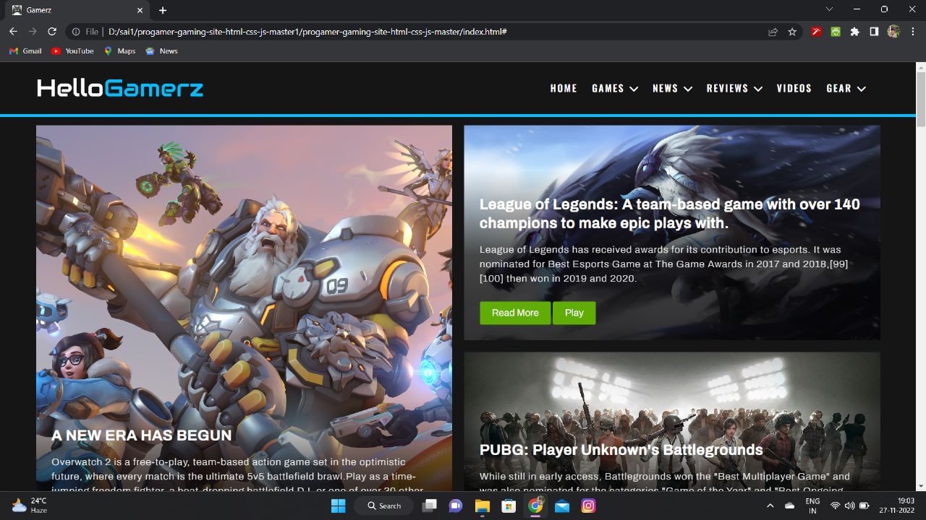

1. **Games :**

In this module we provide different categorised games like Action, Adventure, Arcade, Board, Card, Casino, Casual, Puzzle, Racing, Role Playing, Simulation, Strategy, Trivia, etc,. And we also provide Play stations and Xbox. And we can see the description of the games, so the users can get to know about the gameplay, story of the game, requirements of the system for installing the game. There are many online games and offline games are presented in our website.

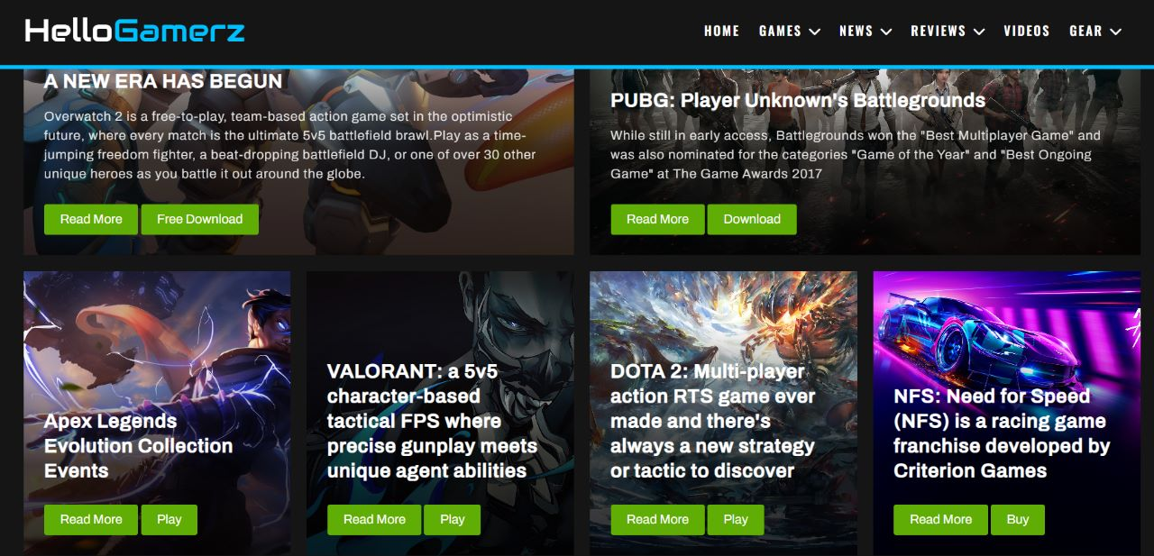

1. **News :**

In this module we provide the launch date of new games, News of the latest version updates. In this module we provide newly received games especially recent games. In news module the game developers will be announced about tournaments, events of the games. By this events news the players can be get to know about participations in tournaments.

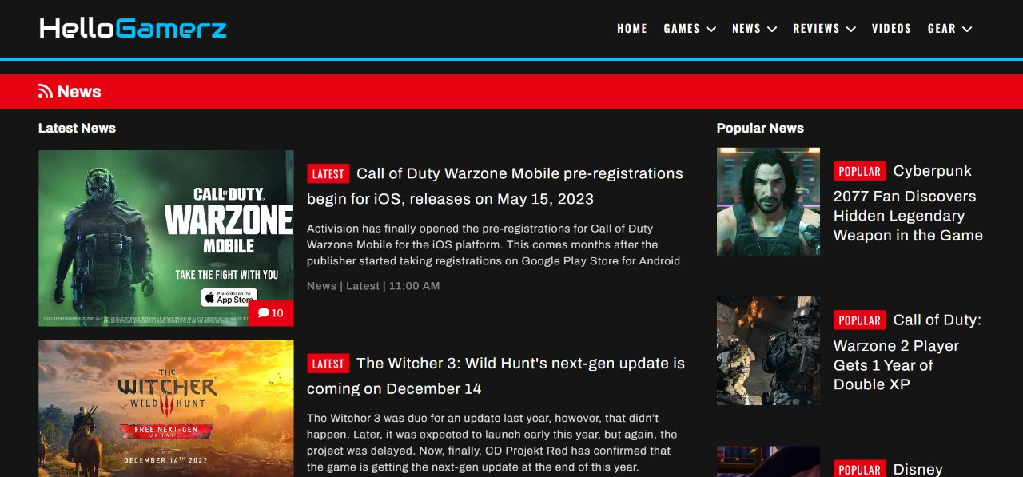

1. **Reviews :**

In this page the user get to know the user based reviews of games. The users can also give reviews on there gaming experience of the games. In review section users can share the game qualities like graphics of the game, story of the game, controls of the game, and more. The players can give there feedback to the games, so the developers can get to know about there games and they can modify to gamers requirements.

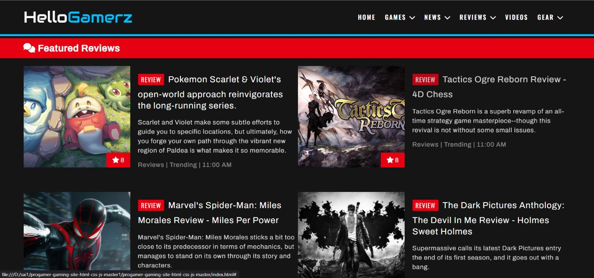

1. **Videos :**

Here the user can see the trailers of the games, clips of the games, strategies of the games, video lectures of the games, screen records of the games, and more about games.

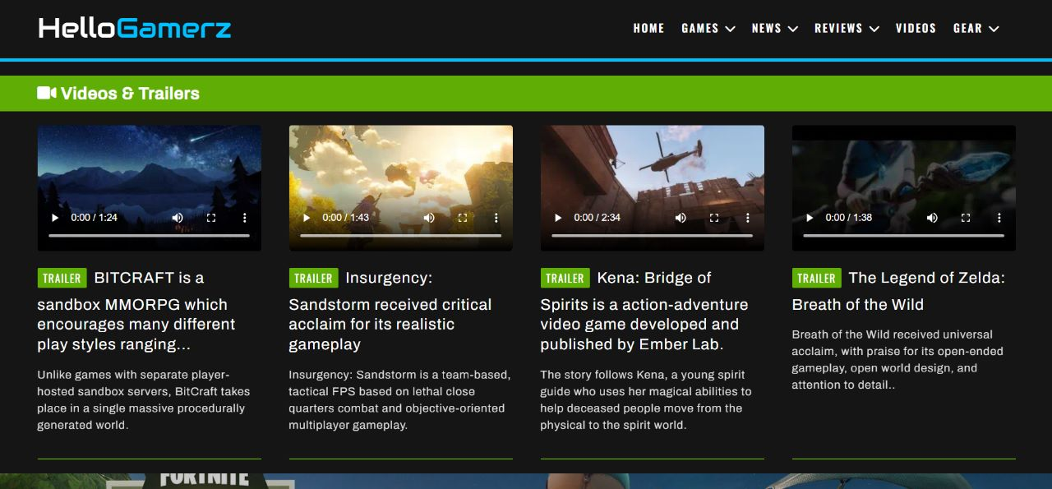

1. **Contact us:** Here the user can contact us for any query . By fill up the following sections .

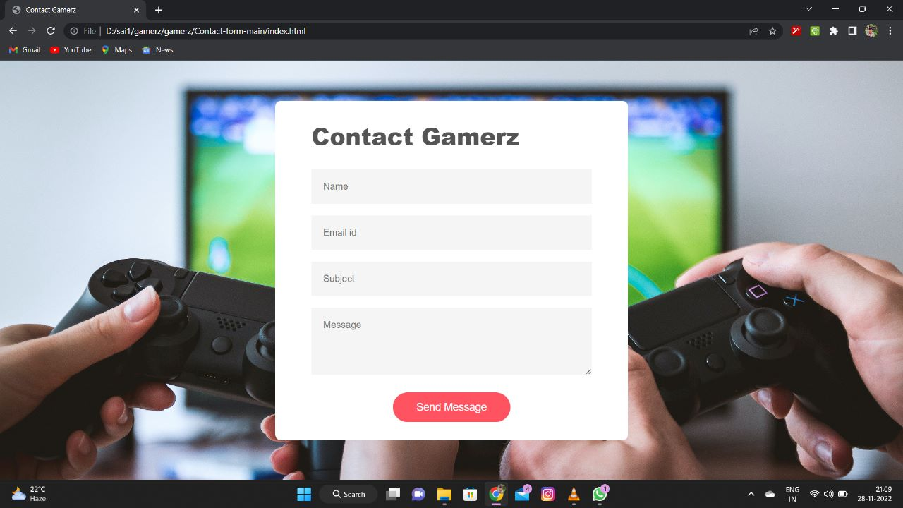

On the basis of the requirements demanded by the user the following project

requirements are found out:

• There are mainly 8 games are included with different tastes.

• Simple and attractive interface is provided for user.

• Users will be able to register and login to get their account from which user

can play games.

• Multiplaying option for the game Bingo is provided for more fun.

• Chat box enables the users to interact with other users while gaming.

• Message from various users are notified instantly.

**Free Games :**

Here are some games which are included in our website where user can play free within online and even they can download the game in their PC’s and play it.

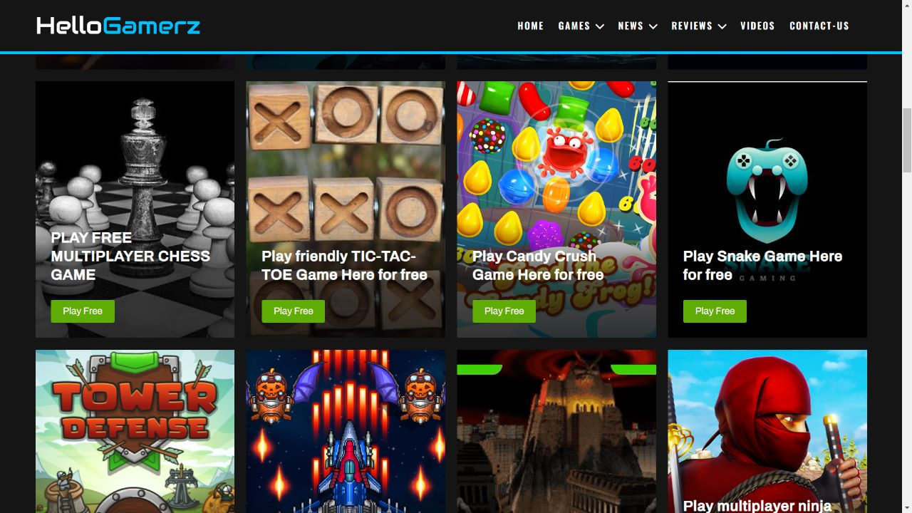

**Agile Model:**

Agile model is selected for the project. We are planning to implement the

system with basic facilities only. So many future enhancements are possible with

this model. Agile model can satisfy this requirement efficiently. Since it follows the

plan-do-check-act for improvement, backtracking can done easily in Agile model.

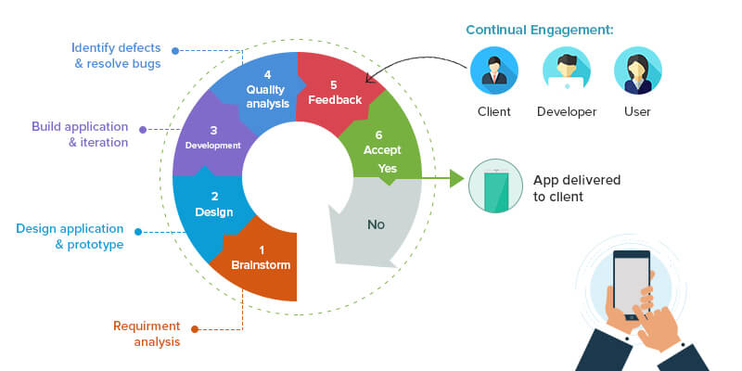

**Use Case View**

The service provided by the Online Game Hub is : First the request is send

from the user to the server which then process and retrieves the requested data from

the database.

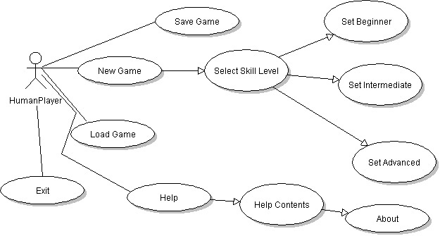

**User Perspective**

Presently, there are lots of online gaming websites available. But multiplaying

options are not available for the games.Some of these websites are less interactive

to the user.There are lots of people they are stressed with their job complexity have

much pleasure and relaxation from these games.Chat system is included for users

interactions.

• The main stream users of the proposed system are the users who play games

for depression removing.

• Another important users of this system are those who play such games just for

Fun.

**Financial Feasibility:**

**1 Development Cost**

For developing an application no particular cost is required. But devices are

needed to demonstrate its working. The only cost required is the cost of devices

needed for demonstration of the working Application.

**2 Installation Cost**

No particular installation cost is needed other than the cost of hardware devices.

**3 Operational Cost**

Execution of the application does not actually require any operational cost. The

only operational cost required is the cost of power supplies to hardware devices as

well as the connectivity charges.

**4 Maintenance Cost**

No particular maintenance cost is needed for this software.

**Revenue Generation In Game Development:**

Game industry is the business associated with the turn of events, promoting, and adaptation of computer games. It incorporates many occupation disciplines and is utilized by a large number of individuals around the world.

From the 1970s, the gaming business has taken extraordinary jumps and limits as far as its advancement. Probably the most punctual PC games during the 1970s were Computer Space, an arcade game, just as Atari’s Pong.

The business saw a stoppage in development in 1977, however at a certain point a development spurt happened when Space Invaders made $2 billion in the mid 1980s to 1982. In spite of this achievement, the 1980s were fierce for the gaming business, particularly due to the business crash in the year 1983. One justification behind the accident was that PC game designers were making unacceptable games. By the end of 1980s, the renowned Japanese organization Nintendo entered the market. They carried a huge restoration to the gaming business by their games control center like the Nintendo Entertainment System and the convenient Gameboy.

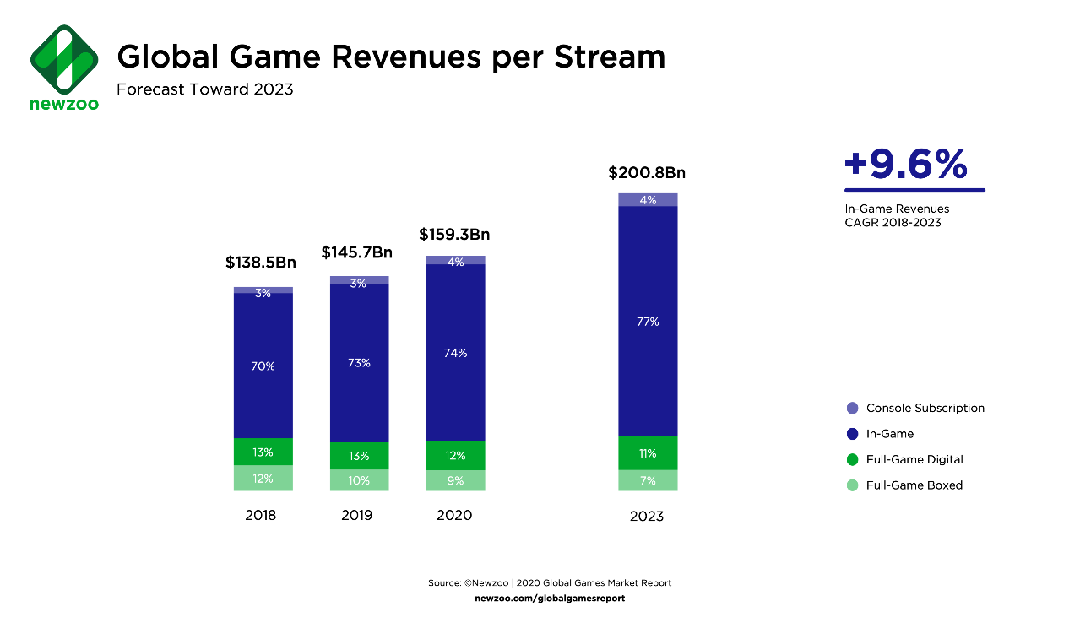

After the 1990s, an abundance of innovations headed in the business, like broad utilization of the minimal plate, also called the CD. These capacity gadgets were utilized to store and circulate gaming programming, including that of the principal Sony Playstation. This decade likewise saw the expanded utilization of graphical GUIs, or UI, which permits a client to collaborate with programming utilizing pictures or symbols. These progressions powered the illumination in the gaming industry.

The game industry has developed from centered business sectors to standard in the new years. In 2018, video games created deals of US$134.9 billion yearly around the world. In 2007, the US ranges to US$ 9.5 billion, in 2008 it is1.7 billion, and in 2010 it is 25.1 billion, as indicated by the ESA yearly report.

The 21st century has been known for the development of portable gaming. Versatile gaming programming is grown fundamentally for gadgets ruling the iOS and Android working framework. Hence these games are normally played on smartwatches, mobile phones, and tablets. PC and versatile gaming keep on gaining recognition and in this way, organizations are creating noteworthy income.

In the previous year, the development of game clients has carried enormous changes to the game business. One clear impact of these innovations are rounding up business for generating more billions in income. Thus, there is an immense chance for administrators like game designers, advertisers, etc.

**Versatile Game insights for 2020**

To represent how quick the versatile gaming industry has grown in 2020 by inspecting its measurements. As it is evident that many changes happened and can be gathered these insights into various classes to make things simple for you to understand



**Income Statistics**

With a monstrous turnout of $77.2 billion dollars the versatile game industry is one of the greatest performing businesses all around the world in 2020the recent year, there is no indication of dialing back in 2021.

There has been a recorded 12% expansion in the quantity of players since 2019. The portable gaming industry recorded over 2.5 billion players. With development actually limited and individuals restricted to their homes, it’s anticipated that the number will just go higher this year.

Lockdown started a flood in the quantity of gamers during the pandemic and gamers spent more than $19 billion on versatile games in 2020’s subsequent quarter. Around 25% of all iOS application downloads and 21% of all versatile games Android application downloads with numerous financial bankers and designers rolling out with remarkable games in 2022.

**Portable game media purchasing patterns**

It is evident that 2020 was a decent year for portable game media purchase as it encountered monstrous development. Portable game sponsors expanded by 9% from the earlier year to 60,000. These publicists made up an enormous lump of 24 % versatile application sponsors.

**Versatile Game innovative patterns**

Insights highlight puzzle games as one of the 2020’s greatest victors. For example, the world’s driving commercial platform SocialPeta encountered the making of 12M creatives inside the year. 25% among them were puzzle game creatives and later came game creatives with role play creativity followed by arcade.

**Versatile Game patterns expectation in 2022**

Throughout 2021, many advancements happened in the portable game development office. Game brands are spending more and more on promoting speculation to draw in more clients and corner adequate portions of the overall industry.

Let’s assume the working expenses surpass created income and all things considered as decrease in income can even cause an emergency for the versatile game industry and hamper its endurance. To fight this, versatile game organizations lay down various portable game patterns with an arrangement to profit by them and shore up their income.

**Role Play and Streaming of Tech Companies**

Gaming organizations such as Apple, Facebook and Google are getting into the business and are searching for ways of making computer game spilling as normal as streaming a film on Netflix or a tune on Spotify.

**Conclusion:**

The project has been completed successfully as specified by the requirements.

The implementation and testing has been done in a step-by-step manner. Each

module has been developed and tested individually to obtain the required output

in the desired form. On our way working on this interesting project, we learned

many things.While working on this project, we got valuable experience on the stages

involved while developing any web application that could be useful while working for

a professional company. During the duration of this project we learned the following

things through the implementation and testing of the project:

• PHP server scripting

• MySQL database management.

• Javascript,Jquery, CSS

• Bootstrap for UI/UX.

• Ajax for UI/UX.

The future improvements can be made in certain areas of the project. There is

scope for extending the project to incorporate more features by including more games

with muktiplayer option,Advanced messaging system with notification,etc. The process model selected is agile model. So that the new options can be implemented

to the same design in later point of time. The updation of the application is an

important feature of agile process model designs.

**Future Increments:**

The future enhancements of the proposed system that we have estimated are

given below.

• Including more games to the system.

• Extending multiplayer options for more games.

• Improving the message system.

• Including advanced methods for notification.

• There is always possibility of enhancing UI/UX(User Interface/User Experience) and Responsive Design.

* Game developers predict streaming will become the dominant platform by 2025.
* Remote teams across time zones are the new normal.
* Most game dev teams are doing at least some of their development in the cloud.
* Creatives are a larger part of the game development process than ever before.